# Chapter 13. Methods for solving nonlinear equations

## 13.1 Types of nonlinear equations

An equation of the form f(x) = 0 is called nonlinear if it has an algebraic or transcendental form and depends on a single argument (for example, from x).

The algebraic form is a polynomial of degree n, where n != 1 (figure 13.1).

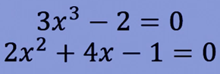

Figure 13.1 – Algebraic equations

The transcendental view is an equation containing various special functions (figure 13.2).

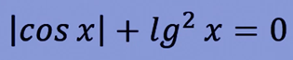

Figure 13.2 – The transcendental equation

## 13.2 Newton's method – tangent method

The method is based on the construction of tangents to the graph, which originate at one of the ends of the interval (a, b) or at any point of it [35].

Conditions of application of the method:

1. The interval (a, b) is known at which the root is defined, in which the function is monotonic and continuous, otherwise the method will not converge (the tangent cannot be built at the point of discontinuity).
2. To select a point, it is better to use the conditions: f(a) * f’(a) > 0 or f(b)*f’(b) > 0 – for faster convergence

The method itself is as follows:

1. Taking the starting point from condition 2
2. A tangent is drawn from the starting point x0 to the intersection with the Ox axis.
3. Denote the resulting point x1, repeat step 2.

These iterations will be repeated until the condition | x(i) – x(i-1) | <= e is satisfied, where e is the required accuracy (figure 13.3).

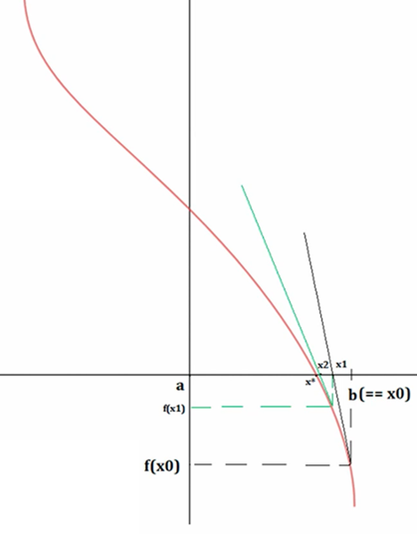

Figure 13.3 – Graph of the Newton method

Each subsequent X will be found using this formula:

$$x_{i}=x_{i-1}-\frac{f(x_{i-1})}{f'(x_{i-1})}$$

Derivation of the root search formula for Newton's method:

1. The geometric meaning of the first derivative is the tangent of the angle of inclination of the tangent to Ox, that is, f'(x0) = tg(a) = k;
2. Write down the equation of a straight line with an angular coefficient

y = k*x+ b;

1. Find the equation of the tangent at point x0:

f(x0) = f'(x0) * x0 + b;

1. Express b: b = f(x0)-f'(x0) * x0;
2. Now write down the tangent equation in a new form, substituting the expression b obtained in paragraph 4:

y=f'(x0) *x+f(x0)-f'(x0) *x0

1. Transform the equation by taking out the common factor f'(x0):

y=f'(x0) * (x-x0) + f(x0)

1. To find the intersection point of the equation from point 6 with the Ox axis, the equation is equated to zero:

f'(x0) * (x -x0) + f(x0) = 0

1. We express the x - intersection of the tangent equation with Ox:

$$x=x_{0}-\frac{f\left(x_{0}\right)}{f^{'\left(x_{0}\right)}}$$

Let us be given an increasing function y = f(x) = x^2-2, continuous on the segment (0;2) and having f'(x) = 2x > 0 and f"(x) = 2 > 0.

1. The tangent equation in general has the following representation:

y-y0=f'(x0)*(x-x0).

In our case: y-y0=2x0 (x-x0). As a point x0, select point B1(b; f(b)) = (2,2). Draw a tangent to the function y = f(x) at point B1 and mark the intersection point of the tangent and the Ox axis with point x1. We obtain the equation of the first tangent:

y-2=2*2(x-2), y=4x-6.

The intersection point of the tangent and the Ox axis is: x1 = 1,5

2. Then we find the intersection point of the function y = f(x) and the perpendicular drawn to the Ox axis through point x1, we get point B2 =(1.5; 0.25). Again, draw the tangent to the function y = f(x) at point B2 and denote the intersection point of the tangent and the Ox axis with point x2.

Equation of the second tangent: y-0,25=2*1,5(x-1,5), y = 3x - 4,25.

The intersection point of the tangent and the Ox axis is:

3. Then we find the intersection point of the function y= f(x) and the perpendicular drawn to the Ox axis through the point x2, we get the point B3 and so on.

4. The first approximation of the root is determined by the formula: $x_{1}=x_{0}-\frac{f\left(x_{0}\right)}{f^{'}\left(x_{0}\right)}=1.5$

The second approximation of the root is determined by the formula:

$$x_{2}=x_{1}-\frac{f\left(x_{1}\right)}{f^{'}\left(x_{1}\right)}=\frac{4.25}{3}≈1.416$$

The third approximation of the root is determined by the formula:

$$x_{3}=x_{2}-\frac{f\left(x_{2}\right)}{f^{'}\left(x_{2}\right)}≈1.414215$$

## 13.3 The method of half division – dichotomy method

This method is applicable if:

1. The interval [a; b] is known at which the function is monotonic and continuous.

2. f(a) * f(b) < 0

The essence of the half division method is to divide the interval [a,b] in half С = (a+b) / 2

and discard the part of the interval in which the root is missing, i.e. the condition F(a)*F(b)<0 is not executed.

The remaining part is a new segment, and iterations will continue until the distance between a an and is less than or equal to ↋ - required accuracy [30].

Example:

It is necessary to solve the equation x^3 - 0.2x^2 + 0.5x + 1.5 = 0 with an accuracy of < 0.001 on the segment [-1.0]

1. Denote the start and end points of the segment with the symbols a and b, respectively. In general, the equation has the form:

F(x)=x^3 - 0,2х^2 + 0,5х + 1,5

2. Divide the segment into 2 parts: (a-b)/2 = (-1+0)/2=-0,5

3. If the product is F(a)*F(x)>0, then the beginning of segment a is transferred to x (a=x), otherwise, the end of segment b is transferred to the point x (b=x).

We divide the resulting segment in half again and so on. The entire calculation is reflected in the table below (figure 13.4). The root is any boundary after the end of iterations (figure 13.5).

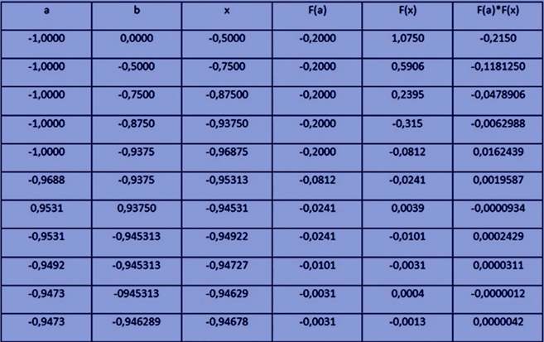

Figure 13.4 – Calculation table

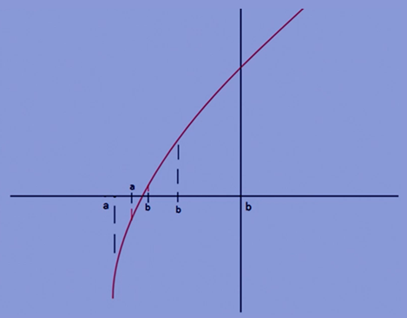

Figure 13.5 – X point selection graph

## 13.4 Iteration method

The essence of the method is to find the approximate

value of the value of the next approximation. The method allows you to obtain a solution with a given accuracy in the form of a limit of a sequence of iterations. The nature of convergence and the very fact of convergence of the method depends on the choice of the initial approximation of the solution[5].

1. This method is applicable if.
2. The isolation interval of the root (x* ∈ [a; b]).
3. The absolute value of the derivative of the new function is less than 1 (|f’(х*)|< 1).

The algorithm is as follows:

1. Equation (1) f(x) = 0 is converted into an equation of the form x = $φ$ (x) (Select x from f(x) = 0 or multiply both parts of equation (1) by a constant and then add x) (Figure 13.6).

2. The initial approximation $x_{1}$ ∈ [a; b] is selected

3. The following approximation to x* is calculated:

4. Exit the loop under the condition || <=ε, otherwise at each iteration of the loop $x_{1}={x^{'}}_{1}$ (Figure 13.7)

Note: the symbol “ ′ ” in ${x^{'}}_{1}$ means the changed value of $x_{1}$

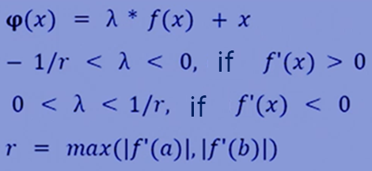

Figure 13.6 – The formula for converting the equation f(x)=0 into an equation of the form x = φ(x)

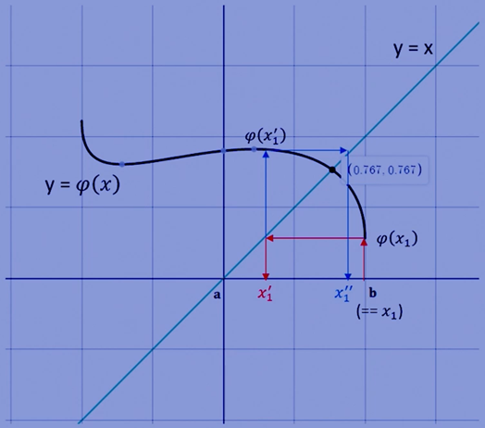

Figure 13.7 – Graph for the iteration method

The iterative method contains one constraint: |f'(x*)|< 1, where x* is the exact root of the equation. f'(x*) is the tangent of the angle of inclination of the tangent to Ox at point x* (at the intersection point y = x  and (x)). The module in the expression |f'(x*)| is necessary to take into account that the tangent can have negative values.

Revealing the module in the expression |f'(x*)|< 1, we get that

-1 <tga(==f'(x*)) < 1. That is, the angles of inclination can take the following values: 135°< a<= 180° , 0°<=a< 45°